**Tugas Logika dan Algoritma**

**Trace Table**

Nama : Irvan Aditya Kurniawan

Kelas : 1 D4 IT B

NRP : 3124600044

**Untuk Masing-masing Soal :**

1. **Sebutkan Tujuan Flowchart**
2. **Buatlah Trace Table**

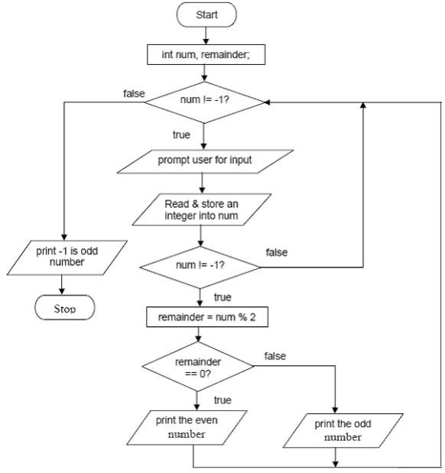

* **Tujuan :** Flowchart tersebut bertujuan untuk meminta input bilangan bulat kepada user kemudian melakukan pengecekan bilangan tersebut ganjil/genap dan menampilkan hasilnya. Hal ini terus berulang sampai user memberikan input -1 yang nantinya langsung mencetak -1 is odd number dan mengakhiri program.
* **Trace Table Soal 1 :**

|  |  |  |  |  |
| --- | --- | --- | --- | --- |
| Langkah | num | reminder | Kondisi | Output |
| Start |  |  |  |  |
| Inisialisasi num, reminder |  |  |  |  |
| num != -1 ? |  |  | True |  |
| Prompt user input |  |  |  |  |
| Store input into num | 5 |  |  |  |
| num != -1 ? |  |  | True |  |
| Reminder = num % 2 |  | 1 |  |  |
| Reminder == 0 ? |  |  | False |  |
| Print the odd number |  |  |  | The odd number |
| Num != -1 ? |  |  | True |  |
| Prompt user input |  |  |  |  |
| Store input into num | -1 |  |  |  |
| Num != -1 ? |  |  | false |  |
| Num != -1 ? |  |  | false |  |
| Print -1 is odd number |  |  |  | -1 is odd number |
| Stop |  |  |  | Program Ended |

1. 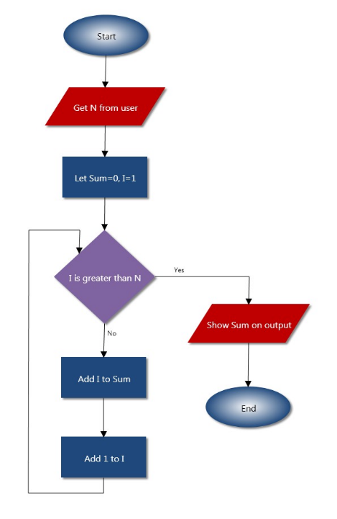

* **Tujuan :** Flowchart tersebut bertujuan untuk meminta input bilangan bulat kepada user kemudian melakukan perhitungan triangular dimana akan menjumlahkan mulai dari 1 sampai ke-N dan nantinya hasil penjumlahan tersebut dimasukkan kedalam variabel sum.
* **Trace Table Soal 2 :**

|  |  |  |  |  |  |
| --- | --- | --- | --- | --- | --- |
| Langkah | N | Sum | I | Kondisi | Output |
| Start |  |  |  |  |  |
| Get N from user | 3 |  |  |  |  |
| Let Sum = 0; I = 1 |  | 0 | 1 |  |  |
| I > N ? |  |  |  | False |  |
| Add I to Sum |  | 1 |  |  |  |
| Add 1 to I |  |  | 2 |  |  |
| I > N ? |  |  |  | False |  |
| Add I to Sum |  | 3 |  |  |  |
| Add 1 to I |  |  | 3 |  |  |
| I > N ? |  |  |  | False |  |
| Add I to Sum |  | 6 |  |  |  |
| Add 1 to I |  |  | 4 |  |  |
| I > N ? |  |  |  | true |  |
| Show Sum on Output |  |  |  |  | Sum = 6 |
| End |  |  |  |  | Program Ended. |

1. 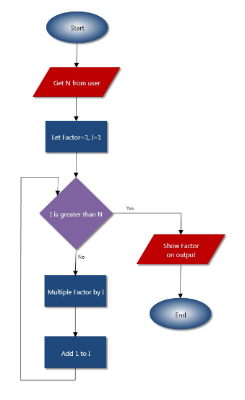

* **Tujuan :** Flowchart tersebut bertujuan untuk meminta input bilangan bulat kepada user kemudian melakukan perhitungan faktorial dimana akan mengalikan bilangan secara berurutan mulai dari 1 sampai ke-N dan hasilnya akan dimasukkan kedalam variabel factor
* **Trace Table Soal 3 :**

|  |  |  |  |  |  |
| --- | --- | --- | --- | --- | --- |
| Langkah | N | Factor | I | Kondisi | Output |
| Start |  |  |  |  |  |
| Get N from user | 3 |  |  |  |  |
| Let Factor = 1; I = 1 |  | 1 | 1 |  |  |
| I > N ? |  |  |  | False |  |
| Multiply Factor by I |  | 1 |  |  |  |
| Add 1 to I |  |  | 2 |  |  |
| I > N ? |  |  |  | False |  |
| Multiply Factor by I |  | 2 |  |  |  |
| Add 1 to I |  |  | 3 |  |  |
| I > N ? |  |  |  | False |  |
| Multiply Factor by I |  | 6 |  |  |  |
| Add 1 to I |  |  | 4 |  |  |
| I > N ? |  |  |  | true |  |
| Show Factor on Output |  |  |  |  | Factor = 6 |
| End |  |  |  |  | Program Ended. |

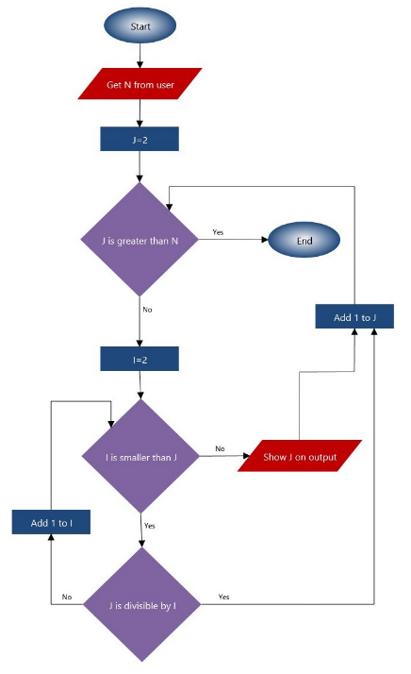

* **Tujuan :** Flowchart tersebut bertujuan untuk meminta input bilangan bulat kepada user kemudian mencari dan mencetak bilangan prima dari 2 hingga ke-N.
* **Trace Table Soal 4 :**

|  |  |  |  |  |  |
| --- | --- | --- | --- | --- | --- |
| Langkah | N | J | I | Kondisi | Output |
| Start |  |  |  |  |  |
| Get N from User | 5 |  |  |  |  |
| J = 2 |  | 2 |  |  |  |
| J is greater than N ? |  |  |  | False |  |
| I = 2 |  |  | 2 |  |  |
| I is smaller than J ? |  |  |  | False |  |
| Show I on output |  |  |  |  | 2 |
| Add 1 to J |  | 3 |  |  |  |
| J is greater than N ? |  |  |  | False |  |
| I = 2 |  |  | 2 |  |  |
| I is smaller than J ? |  |  |  | True |  |
| J is divisible by I ? |  |  |  | False |  |
| Add 1 to I |  |  | 3 |  |  |
| I is smaller than J ? |  |  |  | false |  |
| How J on output |  |  |  |  | 2, 3 |
| Add 1 to J |  | 4 |  |  |  |
| J is greater than N |  |  |  | false |  |
| I = 2 |  |  | 2 |  |  |
| I is smaller than J ? |  |  |  | True |  |
| J is divisible by I ? |  |  |  | True |  |
| Add 1 to J |  | 5 |  |  |  |
| J is greater than N ? |  |  |  | False |  |
| I = 2 |  |  | 2 |  |  |
| I is smaller than J ? |  |  |  | True |  |
| J is divisible by I ? |  |  |  | False |  |
| Add 1 to I |  |  | 3 |  |  |
| I is smaller than J ? |  |  |  | True |  |
| J is divisible by I ? |  |  |  | False |  |
| Add 1 to I |  |  | 4 |  |  |
| I is smaller than J ? |  |  |  | True |  |
| J is divisible by I ? |  |  |  | False |  |
| Add 1 to I |  |  | 5 |  |  |
| I is smaller than J |  |  |  | False |  |
| Show J on output |  |  |  |  | 2, 3, 5 |
| Add 1 to J |  | 6 |  |  |  |
| J is greater than N |  |  |  | True |  |
| End |  |  |  |  | Program Ended. |

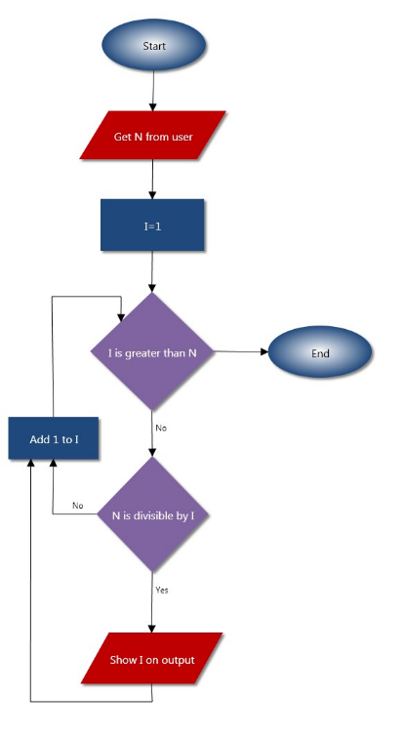

* **Tujuan :** Flowchart tersebut bertujuan untuk meminta input bilangan bulat kepada user kemudian mencari dan mencetak faktor dari bilangan tersebut.
* **Trace Table Soal 5 :**

|  |  |  |  |  |  |
| --- | --- | --- | --- | --- | --- |
| Langkah | N | Sum | I | Kondisi | Output |
| Start |  |  |  |  |  |
| Get N from user | 3 |  |  |  |  |
| Let Sum = 0; I = 1 |  | 0 | 1 |  |  |
| I > N ? |  |  |  | False |  |
| Add I to Sum |  | 1 |  |  |  |
| Add 1 to I |  |  | 2 |  |  |
| I > N ? |  |  |  | False |  |
| Add I to Sum |  | 3 |  |  |  |
| Add 1 to I |  |  | 3 |  |  |
| I > N ? |  |  |  | False |  |
| Add I to Sum |  | 6 |  |  |  |
| Add 1 to I |  |  | 4 |  |  |
| I > N ? |  |  |  | true |  |
| Show Sum on Output |  |  |  |  | Sum = 6 |
| End |  |  |  |  | Program Ended. |

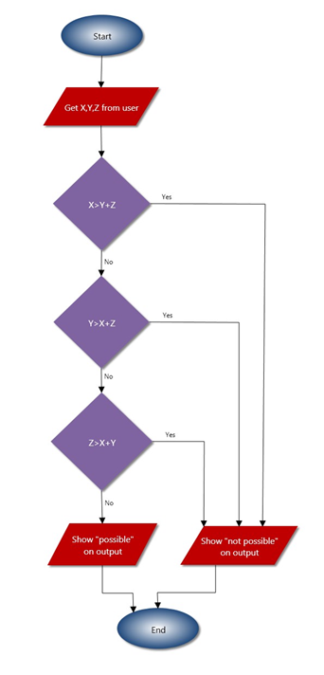

* **Tujuan :** Flowchart tersebut bertujuan untuk pengecekan syarat segitiga, di mana jumlah dua sisi harus lebih besar dari sisi lainnya agar segitiga tersebut dapat terbentuk.
* **Trace Table Soal 6 :**

|  |  |  |  |  |  |
| --- | --- | --- | --- | --- | --- |
| Langkah | X | Y | Z | Kondisi | Output |
| Start |  |  |  |  |  |
| Get X,Y,Z from user | 3 | 5 | 2 |  |  |
| X > Y + Z ? |  |  |  | False |  |
| Y > X + Z ? |  |  |  | False |  |
| Z > X + Y |  |  |  | False |  |
| Show “Possible” Output |  |  |  |  | Possible |

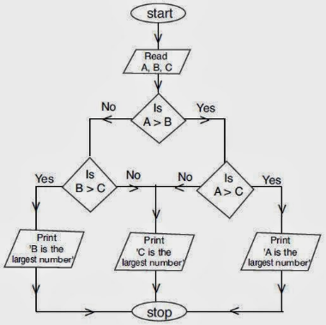

* **Tujuan :** Flowchart tersebut bertujuan untuk mencari angka terbesar dari 3 buah bilangan
* **Trace Table Soal 7 :**

|  |  |  |  |  |  |
| --- | --- | --- | --- | --- | --- |
| Langkah | A | B | C | Kondisi | Output |
| Start |  |  |  |  |  |
| Read A, B, C | 4 | 8 | 1 |  |  |
| Is A > B ? |  |  |  | False |  |
| Is B > C ? |  |  |  | True |  |
| Print B is the Largest Number |  |  |  |  | B is the Largest Number |

1. 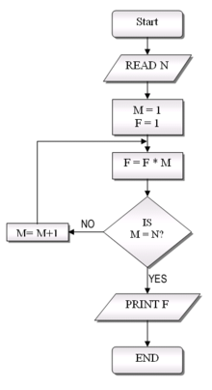

* **Tujuan :** Flowchart tersebut bertujuan untuk menghitung proses faktorial dari bilangan N.
* **Trace Table Soal 8 :**

|  |  |  |  |  |  |
| --- | --- | --- | --- | --- | --- |
| Langkah | N | M | F | Kondisi | Output |
| Start |  |  |  |  |  |
| Read N | 5 |  |  |  |  |
| M = 1, F = 1 |  | 1 | 1 |  |  |
| F = F * M |  |  |  |  |  |
| Is M = N ? |  |  |  | False |  |
| M = M + 1 |  | 2 |  |  |  |
| F = F * M |  |  | 2 |  |  |
| Is M = N ? |  |  |  | False |  |
| M = M + 1 |  | 3 |  |  |  |
| F = F * M |  |  | 6 |  |  |
| Is M = N ? |  |  |  | False |  |
| M = M + 1 |  | 4 |  |  |  |
| F = F * M |  |  | 24 |  |  |
| Is M = N ? |  |  |  | False |  |
| M = M + 1 |  | 5 |  |  |  |
| F = F * M |  |  | 120 |  |  |
| Is M = N ? |  |  |  | True |  |
| Print F |  |  |  |  | 120 |

1. 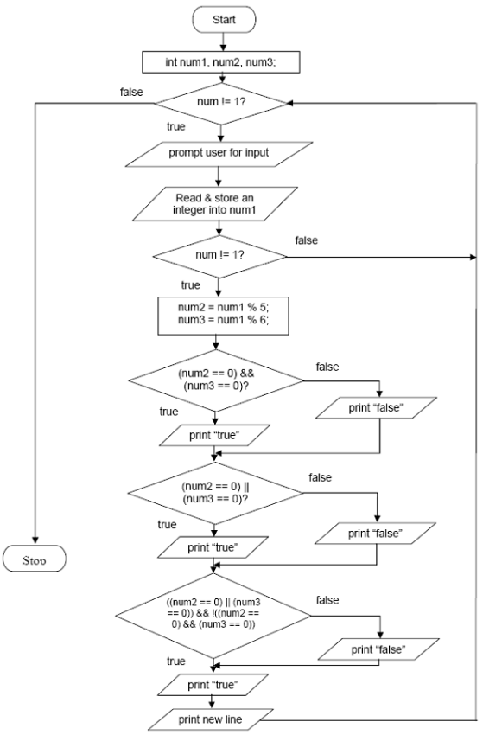

* **Tujuan :** Flowchart tersebut bertujuan untuk mengecek apakan bilangan habis dibagi 5 dan 6 serta memerika apakah bilangan tersebut habis dibagi 5 dan 6 secara bersamaan ataupun tidak.
* **Trace Table Soal 9 :**

|  |  |  |  |  |  |
| --- | --- | --- | --- | --- | --- |
| Langkah | Num 1 | Num 2 | Num 3 | Kondisi | Output |
| Start |  |  |  |  |  |
| Deklarasi Num1, num2, num3 | 0 | 0 | 0 |  |  |
| Num != 1 ? |  |  |  | True |  |
| Prompt user for input |  |  |  |  |  |
| Read and store to num1 | 20 |  |  |  |  |
| Num != 1 ? |  |  |  | True |  |
| Num 2 = Num1 % 5, Num 3 = Num 1 % 6 |  | 0 | 2 |  |  |
| (num2 == 0) && (num3 == 0)? |  |  |  | false |  |
| Print False |  |  |  |  | False |
| Num2 == 0 || num3 == 0 |  |  |  | True |  |
| Print True |  |  |  |  | False True |
| ((num2 == 0) || (num3 == 0)) && !((num2 == 0) && (num3 == 0)) |  |  |  | True |  |
| Print True |  |  |  |  | False True False |
| Print New Line |  |  |  |  |  |
| Num != 1 ? |  |  |  | False |  |
| Stop |  |  |  |  |  |

1. A diagram of a program

   Description automatically generated

* **Tujuan :** Flowchart tersebut bertujuan untuk menjumlahkan angka2 dari bilangan bulat diinputkan user.
* **Trace Table Soal 10 :**

|  |  |  |  |  |  |  |
| --- | --- | --- | --- | --- | --- | --- |
| Langkah | Stop | num | remainder | Sum | Kondisi | Output |
| Start |  |  |  |  |  |  |
| Int num, remainder, sum=0 |  |  |  | 0 |  |  |
| Stop != 1 ? |  |  |  |  | true |  |
| Prompt user for input |  |  |  |  |  |  |
| Read and store into num |  | 123 |  |  |  |  |
| Num != 0 ? |  |  |  |  | True |  |
| Remainder = num % 10, sum = sum + remainder, num = num/10 |  | 12 | 3 | 3 |  |  |
| Print num, remainder |  |  |  |  |  | 12, 3 |
| Num != 0 ? |  |  |  |  | True |  |
| Remainder = num % 10, sum = sum + remainder, num = num/10 |  | 1 | 2 | 5 |  |  |
| Print num, remainder |  |  |  |  |  | 1, 5 |
| Num != 0 ? |  |  |  |  | True |  |
| Remainder = num % 10, sum = sum + remainder, num = num/10 |  | 0 | 1 | 6 |  |  |
| Print num, remainder |  |  |  |  |  | 0, 6 |
| Num != 0 ? |  |  |  |  | False |  |
| Print New Line |  |  |  |  |  |  |
| Print the sum |  |  |  |  |  | 6 |
| Prompt user for input |  |  |  |  |  |  |
| Read and store stop | 1 |  |  |  |  |  |
| Stop != 1 ? | 1 |  |  |  | False |  |
| Stop |  |  |  |  |  |  |

**ARRAY**

* **Tujuan :** Flowchart tersebut bertujuan untuk menjumlahkan semua element pada array yang memniliki 100 elemen.
* **Trace Table Soal 1 :**

|  |  |  |  |  |  |
| --- | --- | --- | --- | --- | --- |
| Langkah | N | SUM | Array | Kondisi | Output |
| Start |  |  | [2, 4, 6, ….] |  |  |
| Sum = 0, N = 0 | 0 | 0 |  |  |  |
| N = 100 ? |  |  |  | False |  |
| Sum = Sum + Array[N] |  | 2 |  |  |  |
| N = N + 1 | 1 |  |  |  |  |
| N = 100 ? |  |  |  | False |  |
| Sum = Sum + Array [N] |  | 6 |  |  |  |
| N = N + 1 | 2 |  |  |  |  |
| Berlanjut Sampai Loop ke 100 | | | | | |
| Output Sum |  |  |  |  | 5050 |
| Stop |  |  |  |  |  |